Practical Skill 1: Reading Error Messages

Broken Code Example: SyntaxError

Corrected Code
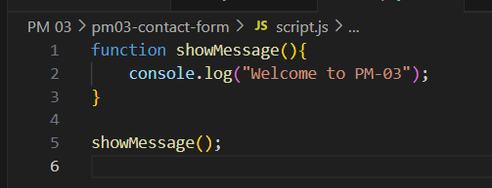
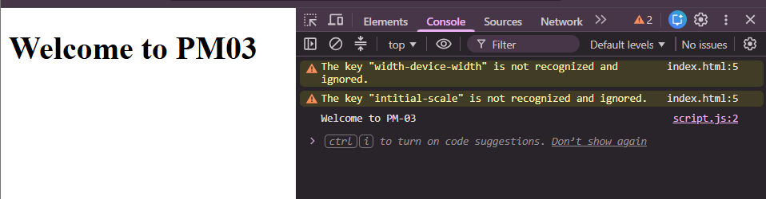

Broken Code Example: ReferenceError

Corrected Code Example:
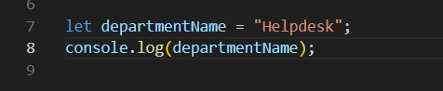
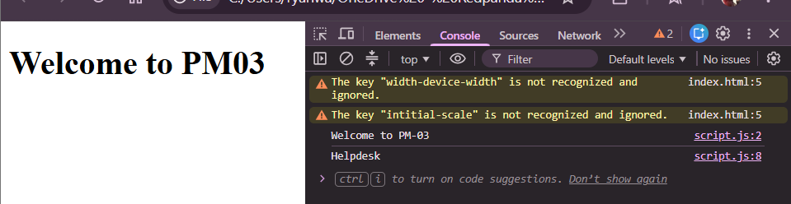

Practical Skill 4: DOM Manipulation

Reading input values
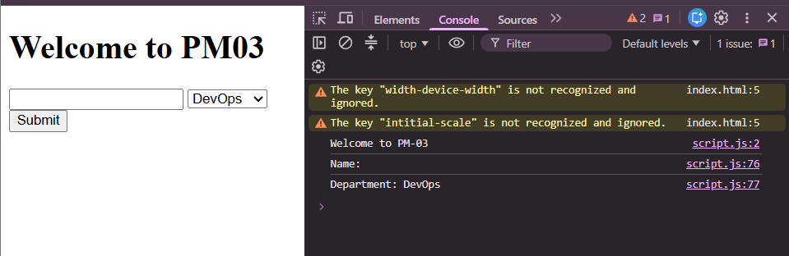

Adding Elements Dynamically
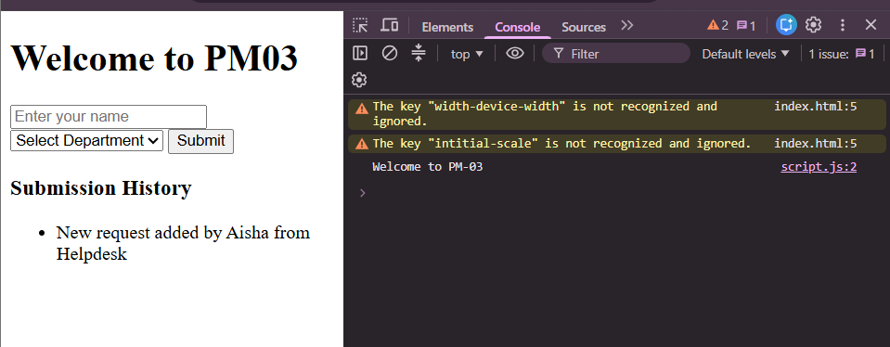

Removing Elements Dynamically
Before:
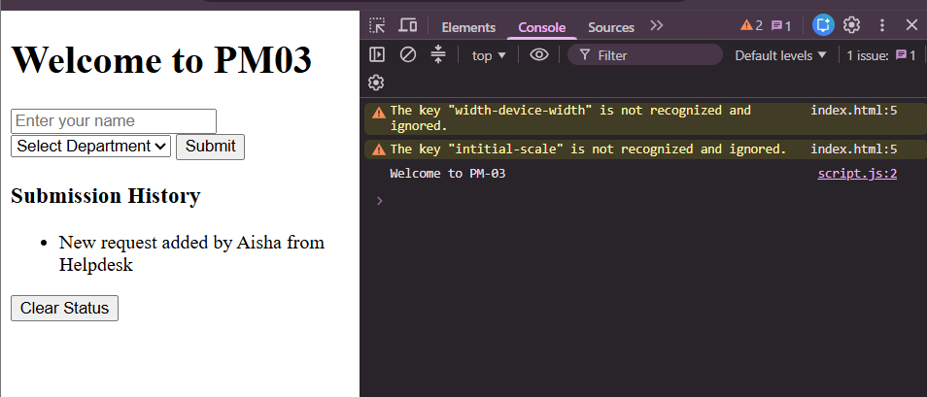
After:
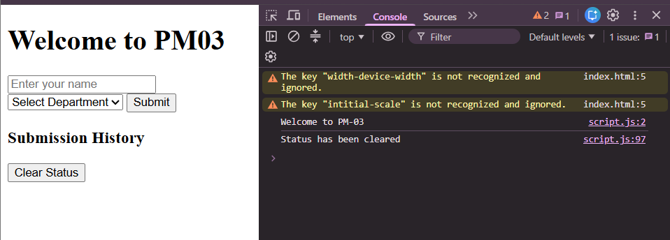

Practical Skill 5: Events

Input Event Example: Character Counter
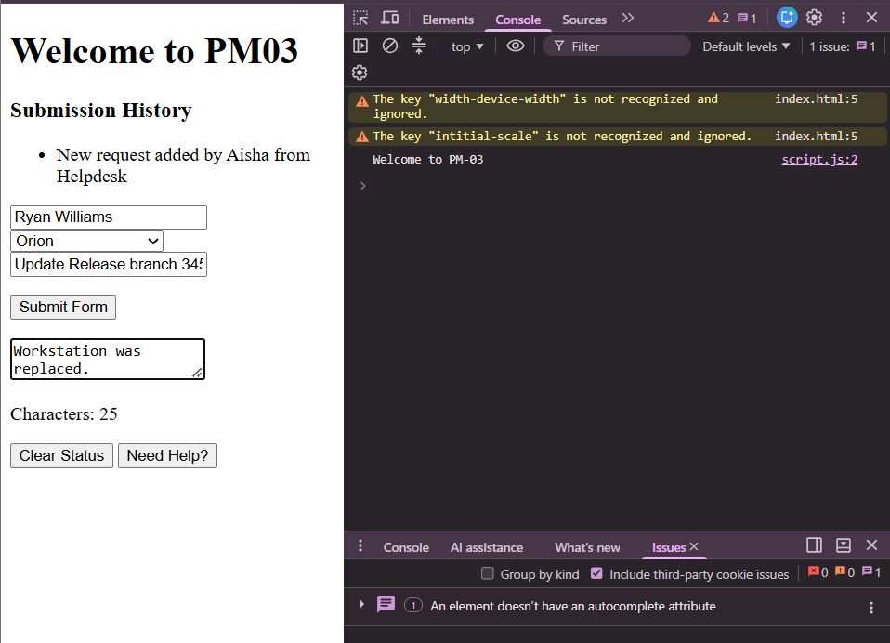

Practical Skill 6: Form Validation

Show message function:
